**Marketing Reach**



**Airport:**

Implementing technology and analytics solutions throughout the whole airport ecosystem is essential to creating a modern, efficient, and profitable airport operation



**Banks:**

The banking sector has embraced the use of technology to serve its client’s faster and also to do more with less. Emerging technologies have changed the banking industry from paper and branch based banks to”digitized and networked banking services.



**Bars:**

Technology could be the tool to get you Success. Whether it is taking inventory, ordering product, managing staff, analyzing sales reports, handling reservations and even correctly pricing your drinks, technology can serve to provide you with the important data and resources to make smart decisions.

**Colleges:**

Online Colleges has taken a look at not just the Internet but all technology that colleges students are using.

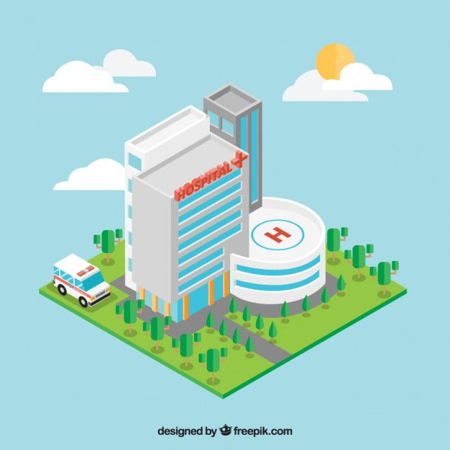

**Hospitals:**

Hospitals that want to keep up need to stay on top of the latest tech trends and incorporate them into patient treatment.



**NGO:**

The internet and social media in particular, has powerful tool for raising awareness for social causes and charity events. Non-government organizations (NGOs) have also adapted to the digital age and use technology to communicate with supporters and donors.

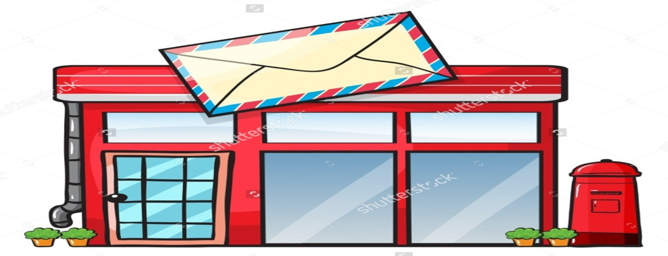

**Post Office:**

The Postal Service has one of the world’s largest computer networks — linking nearly 32,000 facilities and making communication possible between hundreds of thousands of employees and hundreds of systems.



**Restaurant:**

It is important for restaurants to start using latest technologies, and that they expect to use technology more often in the coming year to order food.



**Schools:**

Technology has the power to transform teaching by guiding in a new model of connected teaching. This model links teachers to their students and to professional content, resources, and systems to help them improve their own instruction and personalize learning.

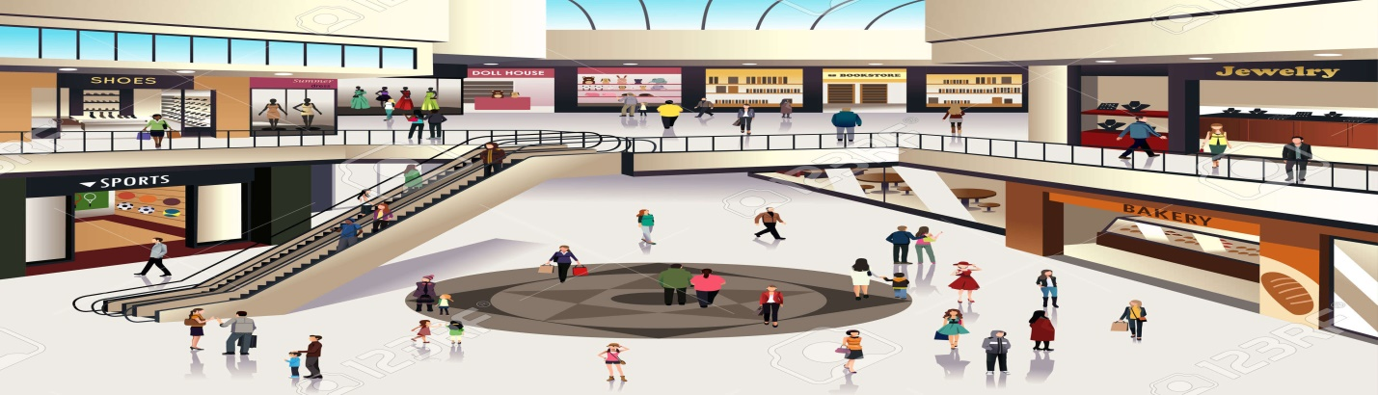

**Shopping Centers:**

While retailers are setting the innovation barrier high, shopping centers using technology to improve their customer offerings.



**YouTube Channel:**

You already know that marketing conferences are a great way to stay connected to changes in the industry, but new changes are happening every day. You can turn to YouTube to keep yourself informed and inspired.